Natural Language Processing and its Techniques Laboratory LAB MANUAL
IFETCE R-2023



IFET COLLEGE OF ENGINEERING
[An Autonomous Institution]
DEPARTMENT OF AIML
SUBJECT CODE : 23AM5L01
YEAR/SEM : III/ V
Prepared by: | Verified by: | Approved by:
Mrs.S.Sangeetha  AP/AIML |  | Dr.S.Usharani HoD/AIML
DEPARTMENT VISION
To be a top center for learning Artificial Intelligence and Machine Learning, guiding students to create a better future in technology and society.
DEPARTMENT MISSION
- To build a strong foundation in Artificial Intelligence and Machine Learning by providing quality education and practical knowledge.
- To empower students with ethical values and skills to make meaningful contributions to society through technology.
- To encourage self-learning and leadership by guiding students to apply their knowledge to solve real-world problems.
- To promote innovation and creativity, inspiring students to contribute to sustainable development and growth.
- To prepare students for success in industry, research, and entrepreneurship at national and international levels.
PROGRAMME OUTCOMES (PO)
On the completion of the program the graduates are expected to know or develop the abilities defined through the Program Outcomes.
The Program Outcomes of Computer Science and Engineering Programme is given below.
PO 1: | Engineering knowledge: Apply the knowledge of mathematics, science, engineering fundamentals, and an engineering specialization to the solution of complex engineering problems.
PO 2: | Problem analysis: Identify, formulate, review research literature, and analyze complex engineering problems reaching substantiated conclusions using first principles of mathematics, natural sciences, and engineering sciences.
PO 3: | Design/development of solutions: Design solutions for complex engineering problems and design system components or processes that meet the specified needs with appropriate consideration for the public health and safety, and the cultural, societal, and environmental considerations.
PO 4: | Conduct investigations of complex problems: Use research-based knowledge and research methods including design of experiments, analysis and interpretation of data, and synthesis of the information to provide valid conclusions.
PO 5: | Modern tool usage: Create, select, and apply appropriate techniques, resources, and modern engineering and IT tools including prediction and modeling to complex engineering activities with an understanding of the limitation.
PO 6: | The engineer and society: Apply reasoning informed by the contextual knowledge to assess societal, health, safety, legal and cultural issues and the consequent responsibilities relevant to the professional engineering practice.
PO 7: | Environment and sustainability: Understand the impact of the professional engineering solutions in societal and environmental contexts, and demonstrate the knowledge of, and need for sustainable development.
PO 8: | Ethics: Apply ethical principles and commit to professional ethics and responsibilities and norms of the engineering practice.
PO 9: | Individual and teamwork: Function effectively as an individual, and as a member or leader in diverse teams, and in multidisciplinary settings.
PO 10: | Communication: Communicate effectively on complex engineering activities with the engineering community and with society at large, such as, being able to comprehend and write effective reports and design documentation, make effective presentations, and give and receive clear instructions.
PO 11: | Project management and finance: Demonstrate knowledge and understanding of the engineering and management principles and apply the set to one’s own work, as a member and leader in a team, to manage projects and in multi-disciplinary environments.
PO 12: | Life-long learning: Recognize the need for, and have the preparation and ability to engage in independent and life-long learning in the broadest context of technological change.

PROGRAMME SPECIFIC OUTCOMES (PSO)
The Artificial Intelligence and Machine Learning Graduates will:
PSO1: Apply theoretical and practical knowledge of Artificial Intelligence and Machine Learning to design innovative and interdisciplinary solutions for real-world challenges.
PSO2: Responsibly integrate ethical values and sustainable practices in the development of AI/ML technologies to address societal and environmental needs.
PSO3: Demonstrate leadership, self-learning, problem-solving, and teamwork skills to excel in industry, research, and entrepreneurial endeavors at global levels.

PROGRAM EDUCATIONAL OBJECTIVES (PEO)

PEO1: Prepare graduates with a strong foundation in Artificial Intelligence and Machine Learning to design effective solutions for real-world challenges.
PEO2: Develop graduates with ethical values and a commitment to creating sustainable and socially impactful AI/ML technologies.
PEO3: Equip graduates with the skills to excel in industry, research, and entrepreneurship while fostering lifelong learning and global leadership qualities.

SYLLABUS
23AM5L01 |  | Natural Language Processing and its Techniques Laboratory | L | T | P | C
 |  | Natural Language Processing and its Techniques Laboratory | 0 | 0 | 3 | 1.5
LEARNING OBJECTIVES:
- Understand fundamental NLP techniques, including text preprocessing, tokenization, POS tagging.
- Provide deep learning-based models for tasks such as language modeling, sentiment analysis, and text classification.
- Elaborate on word representations, language models, and syntactic structures using N-grams.
- Explain the advanced NLP applications, including machine translation, question answering, text summarization, and speech processing.
- Discuss methods on developing real-time applications using NLP.

LIST OF EXPERIMENTS
- Basic Text Processing operation on a text document.
- Develop a POS tagging and NER system using the spaCy or NLTK library
- Implement the N-gram Language model
- Implement LSA and Topic model.
- Employing HMM for PoS tagging.
- Employing CRF on NER tasks
- Perform dependency parsing using spaCy or Stanford NLP and analyze syntactic structures in a sentence.
- Implement a Seq2Seq model with Attention for translating sentences from English to French.
- Implement sentiment classification using pre-trained BERT embeddings.
- Employing CNN on the text classification task.

TOTAL : 60 PERIODS
COURSE OUTCOMES : After successful completion of this course, students will able to
L302.1: Demonstrate proficiency in text preprocessing techniques, syntactic analysis, and morphological processing.
L302.2: Implement and evaluate various NLP models, including traditional machine learning and deep learning approaches.
L302.3: Analyze and apply language models, word embeddings, and sequence-to-sequence architectures for NLP tasks.
L302.4: Develop and deploy real-world NLP applications such as sentiment analysis, machine translation, and chatbots.
L302.5: Utilize cloud-based platforms and optimization techniques to enhance NLP model .
CO- PO MAPPING
COURSE OUTCOMES | MAPPING WITH PROGRAMME OUTCOMES
COURSE OUTCOMES | PO1 | PO2 | PO3 | PO4 | PO5 | PO6 | PO7 | PO8 | PO9 | PO10 | PO11 | PO12
L302. 1 | 3 | 3 | 2 | 1 | 1 | - | - | - | - | - | - | -
L302. 2 | 3 | 3 | 2 | 1 | 1 | - | - | - | - | - | - | -
L302. 3 | 3 | 3 | 3 | 1 | 1 | - | - | - | - | - | - | 2
L302. 4 | 3 | 2 | 2 | 1 | 1 | - | - | 1 | - | - | - | 2
L302. 5 | 3 | 3 | 2 | 2 | 1 | - | - | 1 | - | - | - | -
CO- PSO MAPPING
COURSE OUTCOMES | PSO 1 | PSO 2 | PSO 3
L302. 1 | 2 | 3 | -
L302. 2 | 2 | 3 | -
L302. 3 | - | 3 | 1
L302. 4 | - | 1 | 3
L302. 5 | - | 3 | 1
3- Strong Correlation,
2 – Medium Correlation,
1- Weak Correlation,
-- No Correlation.

TABLE OF CONTENTS

Sl.No | Date of  Expt. | Name of the Experiment | Page  No | Marks |  |  | Staff  Initial
 |  |  |  | Viva (10) | Expt  (10) | Total (20) | Staff  Initial
1 |  | Basic Text Processing operation on a text document.
2 |  | Develop a POS tagging and NER system using the spaCy or NLTK library
3 |  | Implement the N-gram Language model
4 |  | Implement LSA and Topic model.
5 |  | Employing HMM for PoS tagging.
6 |  | Employing CRF on NER tasks
7 |  | Perform dependency parsing using spaCy or Stanford NLP and analyze syntactic structures in a sentence.
8 |  | Implement a Seq2Seq model with Attention for translating sentences from English to French.
9 |  | Implement sentiment classification using pre-trained BERT embeddings.
10 |  | Employing CNN on the text classification task.
Content Beyond The Syllabus

1. |  | Implement a Sequence model on machine translation tasks using a sequence.
2. |  | Develop Grammar Auto corrector using NLP application.
3. |  | Build an NLP application by implementing morphology
4. |  | Implement the chunking for natural language processing.

Virtual lab

1. |  | Implementation of Text Analysis
2. |  | Implementation of POS tagging - Hidden Markov Model

Ex No: 1 | Basic Text Processing operation on a text document.
Date : | Basic Text Processing operation on a text document.

Aim:
To Study and Implementation of Basic Text Processing operation on a text document.
Procedure:
Step1: Implement the text preprocessing tasks is nltk
Step2: Tokenization: Splitting the sentence into words.
Step3: Sentence segmentation: Splitting the text into individual sentences.
Lower casing: Converting a word to lower case
Step4: Stop words removal: Stop words are very commonly used words (a, an, the, etc.) in the
documents.
Step5: Stemming: Transforming a word to its root form.
Step 6: Lemmatization: Reduces the words to a word existing in the language.
Program:
import nltk
from nltk.tokenize import word_tokenize, sent_tokenize
from nltk.corpus import stopwords
from nltk.stem import PorterStemmer, WordNetLemmatizer
nltk.download('punkt')
nltk.download('stopwords')
nltk.download('wordnet')
# Function to perform basic text processing operations
def text_processing(text):
# Tokenization
tokens = word_tokenize(text)

# Sentence segmentation
sentences = sent_tokenize(text)

# Stopword removal
stop_words = set(stopwords.words("english"))
filtered_tokens = [token for token in tokens if token.lower() not in stop_words]

# Stemming
stemmer = PorterStemmer()
stemmed_tokens = [stemmer.stem(token) for token in filtered_tokens]

# Lemmatization
lemmatizer = WordNetLemmatizer()
lemmatized_tokens = [lemmatizer.lemmatize(token) for token in filtered_tokens]

return tokens, sentences, filtered_tokens, stemmed_tokens, lemmatized_tokens

# Example usage
text = "This is an example sentence. It demonstrates basic text processing operations."
tokens, sentences, filtered_tokens, stemmed_tokens, lemmatized_tokens = text_processing(text)

print("Original Text:")
print(text)
print("")

print("Tokens:")
print(tokens)
print("")

print("Sentences:")
print(sentences)
print("")

print("Filtered Tokens (after stopword removal):")
print(filtered_tokens)
print("")

print("Stemmed Tokens:")
print(stemmed_tokens)
print("")

print("Lemmatized Tokens:")
print(lemmatized_tokens)

Output:
Original Text:
This is an example sentence. It demonstrates basic text processing operations.

Tokens:
['This', 'is', 'an', 'example', 'sentence', '.', 'It', 'demonstrates', 'basic', 'text', 'processing', 'operations', '.']

Sentences:
['This is an example sentence.', 'It demonstrates basic text processing operations.']

Filtered Tokens (after stopword removal):
['This', 'example', 'sentence', '.', 'It', 'demonstrates', 'basic', 'text', 'processing', 'operations', '.']

Stemmed Tokens:
['thi', 'exampl', 'sentenc', '.', 'It', 'demonstr', 'basic', 'text', 'process', 'oper', '.']

Lemmatized Tokens:
['This', 'example', 'sentence', '.', 'It', 'demonstrates', 'basic', 'text', 'processing', 'operation', '.']

Result:
Thus the program for implementation of Basic Text Processing operation has been executed
successfully.

On completion of the above program the following PO’s and PSO’s are attained
CO | MAPPING WITH PROGRAMME OUTCOMES |  |  |  |  |  |  |  |  |  |  |  | PSO’S
CO | PO1 | PO2 | PO3 | PO4 | PO5 | PO6 | PO7 | PO8 | PO9 | PO10 | PO11 | PO12 | PSO1 | PSO2 | PSO3
L302.1 | 3 | 3 | 2 | 1 | 1 | - | - | - | - | - | - | - | 3 | 1 | 3

Ex No: 2 | Develop a POS tagging and NER system using the spaCy or NLTK library
Date :

Aim:
To develop a system in Python using the NLTK library that performs Part-of-Speech (POS) tagging and Named Entity Recognition (NER) on a given text.

Procedure:
- Start
- Import the NLTK library and required modules.
- Load the input text.
- Tokenization: Split the input text into sentences and words using NLTK’s sent_tokenize() and word_tokenize().
- POS Tagging: Assign parts of speech (Noun, Verb, Adjective, etc.) to each token using nltk.pos_tag().
- NER:
- Use nltk.ne_chunk() to detect named entities like Person, Organization, Location etc.
- This produces a parse tree containing named entities.
- Display results for POS tagging and NER.
- Stop

Program:

import nltk
from nltk import word_tokenize, pos_tag, ne_chunk
from nltk.tree import Tree
# Download NLTK resources (only first time)
nltk.download('punkt')
nltk.download('averaged_perceptron_tagger')
nltk.download('maxent_ne_chunker')
nltk.download('words')
# Input text
text = "Barack Obama was the 44th President of the United States. He was born in Hawaii."

# Step 1: Tokenize text
tokens = word_tokenize(text)

# Step 2: POS Tagging
pos_tags = pos_tag(tokens)
print("POS Tagging Result:")
print(pos_tags)

# Step 3: Named Entity Recognition
ner_tree = ne_chunk(pos_tags)
print("\nNamed Entity Recognition Result:")
print(ner_tree)

# Extract named entities from tree
named_entities = []
for subtree in ner_tree:
if type(subtree) == Tree: # If subtree is a named entity
entity_name = " ".join([token for token, pos in subtree.leaves()])
entity_type = subtree.label()
named_entities.append((entity_name, entity_type))

print("\nExtracted Named Entities:")
print(named_entities)

Input Text:
Barack Obama was the 44th President of the United States. He was born in Hawaii.

Output:
Named Entity Recognition Result:
[('Barack', 'NNP'), ('Obama', 'NNP'), ('was', 'VBD'),
('the', 'DT'), ('44th', 'JJ'), ('President', 'NNP'),
('of', 'IN'), ('the', 'DT'), ('United', 'NNP'),
('States', 'NNPS'), ('.', '.'), ('He', 'PRP'),
('was', 'VBD'), ('born', 'VBN'), ('in', 'IN'),
('Hawaii', 'NNP'), ('.', '.')]

Extracted Named Entities:
[('Barack Obama', 'PERSON'), ('President United States', 'ORGANIZATION'), ('Hawaii', 'GPE')]

Result:
Thus, a POS tagging and Named Entity Recognition (NER) system was successfully developed using the NLTK library in Python.
On completion of the above program the following PO’s and PSO’s are attained
CO | MAPPING WITH PROGRAMME OUTCOMES |  |  |  |  |  |  |  |  |  |  |  | PSO’S
CO | PO1 | PO2 | PO3 | PO4 | PO5 | PO6 | PO7 | PO8 | PO9 | PO10 | PO11 | PO12 | PSO1 | PSO2 | PSO3
L302.1 | 3 | 3 | 2 | 1 | 1 | - | - | - | - | - | - | - | 3 | 1 | 3

Ex No: 3 | Implement the N-gram Language model
Date : | Implement the N-gram Language model

Aim:
To implement an N-gram Language Model using Python and the NLTK library for predicting the next word in a sequence based on probability.

Procedure:
- Start
- Import NLTK and required libraries.
- Load the input text corpus.
- Preprocessing:
Convert text to lowercase.
Tokenize text into words.
Remove punctuation if required.
- Generate N-grams using nltk.ngrams().
- Compute frequency counts of N-grams using collections.Counter.
- Build a probability distribution for N-grams.
- Implement a function to predict the next word given a history of (N-1) words.
- Test the model with example inputs.
- Stop

Program:
import nltk
from nltk.util import ngrams
from collections import Counter
nltk.download('punkt')
# Sample text
text = "I love natural language processing and I love Python programming."
# Tokenize text into words
words = nltk.word_tokenize(text.lower())
# Create bigrams (N=2)
bigrams = list(ngrams(words, 2))
# Count bigram frequencies
bigram_freq = Counter(bigrams)
print("Bigrams and their frequencies:")
for bigram, freq in bigram_freq.items():
print(f"{bigram} -> {freq}")
OUTPUT
('i', 'love') -> 2
('love', 'natural') -> 1
('natural', 'language') -> 1
('language', 'processing') -> 1
('processing', 'and') -> 1
('and', 'i') -> 1
('love', 'python') -> 1
('python', 'programming') -> 1

Predicting the Next Word
def predict_next_word(word, bigram_freq):
candidates = {w2: freq for (w1, w2), freq in bigram_freq.items() if w1 == word}
if not candidates:
return None
return max(candidates, key=candidates.get)
# word with max frequency
# Example prediction
current_word = "love"
next_word = predict_next_word(current_word, bigram_freq)
print(f"Next word after '{current_word}' is likely '{next_word}'")

Output
Next word after 'love' is likely 'natural'

Result:
Thus, the N-gram Language Model was successfully implemented using Python’s NLTK library, and it was able to generate next-word predictions based on bigram and trigram probabilities.
On completion of the above program the following PO’s and PSO’s are attained
CO | MAPPING WITH PROGRAMME OUTCOMES |  |  |  |  |  |  |  |  |  |  |  | PSO’S
CO | PO1 | PO2 | PO3 | PO4 | PO5 | PO6 | PO7 | PO8 | PO9 | PO10 | PO11 | PO12 | PSO1 | PSO2 | PSO3
L302.2 | 3 | 3 | 2 | 1 | 1 | - | - | - | - | - | - | - | 3 | 3 | 2

Ex No: 4 | Implement LSA and Topic model.
Date : | Implement LSA and Topic model.

Aim:To implement Latent Semantic Analysis (LSA) using TF-IDF + TruncatedSVD and Topic Modeling using Latent Dirichlet Allocation (LDA), and to interpret topics by top terms and document–topic weights.
Algorithm :
Step 1: Install Required Libraries
Step 2: Import Necessary Libraries
Step 3: Download NLTK Stopwords
Step 4: Prepare the Sample Documents
Step 5: Preprocess the Text Data
Step 6: Perform Latent Semantic Analysis (LSA)
Step 7: Perform Topic Modeling Using Latent Dirichlet Allocation (LDA)
Step 8: Run the Program

pip install numpy pandas scikit-learn gensim nltk
import numpy as np
import pandas as pd
from sklearn.feature_extraction.text import CountVectorizer, TfidfVectorizer
from sklearn.decomposition import TruncatedSVD
from sklearn.preprocessing import normalize
from sklearn.decomposition import LatentDirichletAllocation
import nltk
from nltk.corpus import stopwords

nltk.download('stopwords')

# Sample documents
documents = [
"The sky is blue and beautiful.",
"Love this blue and beautiful sky!",
"The quick brown fox jumps over the lazy dog.",
"A king's breakfast has sausages, ham, bacon, eggs, toast and beans",
"I love green eggs, ham, sausages, and bacon!",
"The brown fox is quick and the blue dog is lazy!",
"The sky is very blue and the sky is very beautiful today",
"The dog is lazy but the brown fox is quick!"
]

# Preprocessing
stop_words = set(stopwords.words('english'))
def preprocess(doc):
return ' '.join([word for word in doc.lower().split() if word not in stop_words])

processed_docs = [preprocess(doc) for doc in documents]

# LSA (Latent Semantic Analysis) using TruncatedSVD
def perform_lsa(documents, num_topics=2):
vectorizer = TfidfVectorizer()
X = vectorizer.fit_transform(documents)

svd_model = TruncatedSVD(n_components=num_topics, random_state=42)
lsa_matrix = svd_model.fit_transform(X)

terms = vectorizer.get_feature_names_out()

for i, comp in enumerate(svd_model.components_):
terms_in_topic = [terms[i] for i in comp.argsort()[:-6:-1]]
print(f"Topic {i+1}: {', '.join(terms_in_topic)}")

return lsa_matrix

print("LSA Topics:")
lsa_matrix = perform_lsa(processed_docs, num_topics=2)

# Topic Modeling using LDA (Latent Dirichlet Allocation)
def perform_lda(documents, num_topics=2):
vectorizer = CountVectorizer()
X = vectorizer.fit_transform(documents)

lda_model = LatentDirichletAllocation(n_components=num_topics, random_state=42)
lda_matrix = lda_model.fit_transform(X)

terms = vectorizer.get_feature_names_out()

for idx, topic in enumerate(lda_model.components_):
terms_in_topic = [terms[i] for i in topic.argsort()[:-6:-1]]
print(f"Topic {idx+1}: {', '.join(terms_in_topic)}")

return lda_matrix

print("\nLDA Topics:")
lda_matrix = perform_lda(processed_docs, num_topics=2)

Output:
LSA Topics:
Topic 1: sky, blue, beautiful, lazy, quick
Topic 2: bacon, sausages, ham, eggs, brown

LDA Topics:
Topic 1: brown, dog, quick, lazy, fox
Topic 2: eggs, bacon, ham, sausages, love

Result : Thus Latent Semantic Analysis (Lsa) Using Tf-Idf + Truncatedsvd And Topic Modeling Using Latent Dirichlet Allocation (Lda), And To Interpret Topics By Top Terms And Document–Topic Weights.

On completion of the above program the following PO’s and PSO’s are attained
CO | MAPPING WITH PROGRAMME OUTCOMES |  |  |  |  |  |  |  |  |  |  |  | PSO’S
CO | PO1 | PO2 | PO3 | PO4 | PO5 | PO6 | PO7 | PO8 | PO9 | PO10 | PO11 | PO12 | PSO1 | PSO2 | PSO3
L302.2 | 3 | 3 | 2 | 1 | 1 | - | - | - | - | - | - | - | 3 | 3 | 2

Ex No: 5 | Employing HMM for PoS tagging.
Date : | Employing HMM for PoS tagging.

Aim:
To write a program for understanding the log-linear model for the PoS tagging problem.
Procedure:
Step 1 : Import Libraries: We import necessary modules from NLTK.
Step 2 : Load Data: We use the Penn Treebank corpus, which is a commonly used dataset for training PoS taggers.
Step 3 : Train the HMM: The HiddenMarkovModelTrainer is used to train an HMM model on the training data.
Step 4 : Evaluate the Model: The trained model is tested on unseen test data, and accuracy is printed.
Step 5 : Tagging a Sentence: Finally, we use the trained model to tag a sample sentence.

import nltk
from nltk.tag import hmm
from nltk.corpus import treebank

# Download required NLTK resources
nltk.download('treebank')
nltk.download('universal_tagset')
# Load a portion of the Penn Treebank corpus
train_data = treebank.tagged_sents(tagset='universal')[:3000]
test_data = treebank.tagged_sents(tagset='universal')[3000:]
# Train an HMM model
trainer = hmm.HiddenMarkovModelTrainer()
hmm_tagger = trainer.train(train_data)
# Test the model
accuracy = hmm_tagger.evaluate(test_data)
print(f"HMM Tagger Accuracy: {accuracy:.4f}")

# Test with a sentence
sentence = "The quick brown fox jumps over the lazy dog".split()
print("Tagged Sentence:")
print(hmm_tagger.tag(sentence))

Output
Tagged Sentence:
[('The', 'DET'), ('quick', 'ADJ'), ('brown', 'ADJ'), ('fox', 'NOUN'), ('jumps', 'VERB'), ('over', 'ADP'), ('the', 'DET'), ('lazy', 'ADJ'), ('dog', 'NOUN')]

Result:
Thus the program for Employing HMM for PoS tagging has been executed successfully.

On completion of the above program the following PO’s and PSO’s are attained
CO | MAPPING WITH PROGRAMME OUTCOMES |  |  |  |  |  |  |  |  |  |  |  | PSO’S
CO | PO1 | PO2 | PO3 | PO4 | PO5 | PO6 | PO7 | PO8 | PO9 | PO10 | PO11 | PO12 | PSO1 | PSO2 | PSO3
L302.3 | 3 | 3 | 3 | 1 | 1 | - | - | - | - | - | - | 2 | 2 | 2 | 2

Ex No: 6 | Employing CRF on NER tasks
Date : | Employing CRF on NER tasks

Aim:
To write a program to demonstrate the Employing Conditional Random Field CRF on named entity recognition NER tasks.
Procedure:
- Start
- Load a dataset with tokenized sentences and word-level entity labels (BIO format).
- Define feature extraction for each word:
Current word, suffix/prefix, capitalization, POS tag, etc.
Previous and next word features.
- Convert the dataset into feature dictionaries + labels.
- Train a CRF model (sklearn-crfsuite).
- Predict labels on test sentences.
- Evaluate performance using metrics (F1-score).
- Stop

Program:

import pandas as pd
from sklearn_crfsuite import CRF
from sklearn_crfsuite import metrics

# Sample training data: list of sentences with word-label pairs
train_data = [
[('John', 'B-PER'), ('lives', 'O'), ('in', 'O'), ('New', 'B-LOC'), ('York', 'I-LOC')]
]

# Sample test data: list of sentences with word-label pairs
test_data = [
[('Mary', 'B-PER'), ('is', 'O'), ('from', 'O'), ('Los', 'B-LOC'), ('Angeles', 'I-LOC')]
]

# Feature extraction function
def extract_features(sentence):
return [{
'word': word,
'is_capitalized': word[0].upper() == word[0],
'is_numeric': word.isdigit(),
'is_upper': word.isupper(),
'is_title': word.istitle(),
'prev_word': sentence[i-1][0] if i > 0 else '',
'next_word': sentence[i+1][0] if i < len(sentence)-1 else ''
} for i, (word, _) in enumerate(sentence)]

# Preparing the training data
X_train = [extract_features(s) for s in train_data]
y_train = [[label for _, label in s] for s in train_data]

# Creating and training the CRF model
crf = CRF(algorithm='lbfgs', max_iterations=100)
crf.fit(X_train, y_train)

# Preparing the test data
X_test = extract_features(test_data[0]) # Testing with "Mary is from Los Angeles"
y_pred = crf.predict_single(X_test)

# Displaying predictions
print("Predicted labels for the test sentence:", y_pred)

# For evaluation, you could print the expected output
expected_labels = [label for _, label in test_data[0]]
print("Expected labels:", expected_labels)

Output

Predicted labels for the test sentence: ['B-PER', 'O', 'O', 'B-LOC', 'I-LOC']
Expected labels: ['B-PER', 'O', 'O', 'B-LOC', 'I-LOC']

Result:
Thus the program to demonstrate the Employing Conditional Random Field CRF on named entity recognition NER task has been executed successfully.

On completion of the above program the following PO’s and PSO’s are attained
CO | MAPPING WITH PROGRAMME OUTCOMES |  |  |  |  |  |  |  |  |  |  |  | PSO’S
CO | PO1 | PO2 | PO3 | PO4 | PO5 | PO6 | PO7 | PO8 | PO9 | PO10 | PO11 | PO12 | PSO1 | PSO2 | PSO3
L302.3 | 3 | 3 | 3 | 1 | 1 | - | - | - | - | - | - | 2 | 2 | 2 | 2

Ex No: 7 | Perform dependency parsing using spaCy or Stanford NLP and analyze syntactic structures in a sentence.
Date :

Aim:
To implement dependency parsing using the spaCy NLP library and analyze the syntactic structure (grammatical relations between words) of a sentence.
Procedure:
- Start
- Load the spaCy language model (e.g., "en_core_web_sm").
- Provide an input sentence.
- Apply the spaCy NLP pipeline to tokenize, POS-tag, and parse dependencies.
- For each token in the sentence:
Print token, its dependency relation, head word, and part of speech.
- Visualize the dependency tree (optional, using displacy).
- Stop

Program:
# ===============================
# Dependency Parsing using spaCy
# ===============================

# Install: pip install spacy
# Download model: python -m spacy download en_core_web_sm

import spacy
from spacy import displacy

# Step 1: Load English model
nlp = spacy.load("en_core_web_sm")

# Step 2: Input Sentence
sentence = "The quick brown fox jumps over the lazy dog."
doc = nlp(sentence)

# Step 3: Print dependency relations
print("Token\tHead\tPOS\tDependency")
for token in doc:
print(f"{token.text}\t{token.head.text}\t{token.pos_}\t{token.dep_}")

# Step 4: Visualize dependency structure in browser
displacy.serve(doc, style="dep")

Input:
The quick brown fox jumps over the lazy dog.

Output:

Token Head POS Dependency
The fox DET det
quick fox ADJ amod
brown fox ADJ amod
fox jumps NOUN nsubj
jumps jumps VERB ROOT
over jumps ADP prep
the dog DET det
lazy dog ADJ amod
dog over NOUN pobj
. jumps PUNCT punct

Result:
The syntactic structure of the input sentence was successfully analyzed using spaCy’s dependency parser. The dependency tree clearly shows grammatical relations between words, helping in semantic understanding of text.

On completion of the above program the following PO’s and PSO’s are attained
CO | MAPPING WITH PROGRAMME OUTCOMES |  |  |  |  |  |  |  |  |  |  |  | PSO’S
CO | PO1 | PO2 | PO3 | PO4 | PO5 | PO6 | PO7 | PO8 | PO9 | PO10 | PO11 | PO12 | PSO1 | PSO2 | PSO3
L302.4 | 3 | 2 | 2 | 1 | 1 | - | - | 1 | - | - | - | 2 | 3 | 2 | 3

Ex No: 8 | Implement a Seq2Seq model with Attention for translating sentences from English to French.
Date :

Aim:
To implement a Seq2Seq model with Attention for translating sentences from English to French.

Procedure:
- Prepare parallel corpus (EN–FR).
- Tokenize and integer-encode English and French; add <sos>, <eos> to French targets.
- Encoder: Embedding → RNN (GRU/LSTM) → sequence of states + final state.
- Attention (Bahdanau): score(h_enc, s_dec) → softmax → context vector.
- Decoder (teacher forcing): At each step, input previous gold token + context → RNN → Dense → softmax over FR vocab.
- Train with cross-entropy loss and mask padding.
- Inference: Encode source; start with <sos>; repeatedly attend + decode greedily until <eos> or max length.

Program:
# ===========================
# EN->FR Seq2Seq with Attention
# ===========================
# pip install tensorflow==2.* (2.10+ recommended)

import tensorflow as tf
from tensorflow.keras import layers
import numpy as np

# -------------------------
# 1) Tiny toy parallel corpus (replace with your dataset)
# -------------------------
pairs = [
("i love you", "je t'aime"),
("how are you", "comment ça va"),
("good morning", "bonjour"),
("thank you", "merci"),
("see you soon", "à bientôt"),
("where are you", "où es-tu"),
("i am fine", "je vais bien"),
("what is your name", "comment tu t'appelles"),
("nice to meet you", "ravi de te rencontrer"),
("good night", "bonne nuit"),
]

# -------------------------
# 2) Tokenization
# -------------------------
from tensorflow.keras.preprocessing.text import Tokenizer
from tensorflow.keras.preprocessing.sequence import pad_sequences

def build_tokenizer(texts, num_words=None, oov="<unk>"):
tok = Tokenizer(num_words=num_words, oov_token=oov, filters="") # keep accents/punct
tok.fit_on_texts(texts)
return tok

en_texts = [en for en, fr in pairs]
fr_texts = [fr for en, fr in pairs]

# Add <sos> and <eos> to targets
fr_in_texts = ["<sos> " + t for t in fr_texts]
fr_out_texts = [t + " <eos>" for t in fr_texts]

tok_en = build_tokenizer(en_texts)
tok_fr = build_tokenizer(fr_in_texts + fr_out_texts)

en_seqs = tok_en.texts_to_sequences(en_texts)
fr_in_seqs = tok_fr.texts_to_sequences(fr_in_texts)
fr_out_seqs = tok_fr.texts_to_sequences(fr_out_texts)

max_len_en = max(len(s) for s in en_seqs)
max_len_fr = max(len(s) for s in fr_out_seqs)

en_seqs = pad_sequences(en_seqs, maxlen=max_len_en, padding="post")
fr_in_seqs = pad_sequences(fr_in_seqs, maxlen=max_len_fr, padding="post")
fr_out_seqs = pad_sequences(fr_out_seqs, maxlen=max_len_fr, padding="post")

en_vocab = len(tok_en.word_index) + 1
fr_vocab = len(tok_fr.word_index) + 1

dataset = tf.data.Dataset.from_tensor_slices((en_seqs, fr_in_seqs, fr_out_seqs)) \
.shuffle(100).batch(16)

# -------------------------
# 3) Model components
# -------------------------
EMB_EN = 64
EMB_FR = 64
RNN_UNITS = 128

class Encoder(tf.keras.Model):
def __init__(self, vocab, emb_dim, rnn_units):
super().__init__()
self.emb = layers.Embedding(vocab, emb_dim, mask_zero=True)
self.rnn = layers.GRU(rnn_units, return_sequences=True, return_state=True)
def call(self, x):
x = self.emb(x) # (B, T, E)
seq, h = self.rnn(x) # seq: (B, T, H), h: (B, H)
return seq, h

class BahdanauAttention(tf.keras.layers.Layer):
def __init__(self, units):
super().__init__()
self.W1 = layers.Dense(units)
self.W2 = layers.Dense(units)
self.v = layers.Dense(1)
def call(self, enc_seq, dec_state, mask):
# enc_seq: (B, T, H), dec_state: (B, H)
dec_state_exp = tf.expand_dims(dec_state, 1) # (B,1,H)
score = self.v(tf.nn.tanh(self.W1(enc_seq) + self.W2(dec_state_exp))) # (B,T,1)
score = tf.squeeze(score, axis=-1) # (B,T)
# mask padding positions
if mask is not None:
score = tf.where(mask, score, tf.fill(tf.shape(score), -1e9))
attn = tf.nn.softmax(score, axis=1) # (B,T)
context = tf.matmul(tf.expand_dims(attn, 1), enc_seq) # (B,1,H)
context = tf.squeeze(context, axis=1) # (B,H)
return context, attn

class Decoder(tf.keras.Model):
def __init__(self, vocab, emb_dim, rnn_units, attention):
super().__init__()
self.emb = layers.Embedding(vocab, emb_dim, mask_zero=True)
self.rnn = layers.GRU(rnn_units, return_state=True)
self.fc = layers.Dense(vocab)
self.attn = attention
def call(self, y_prev, state, enc_seq, enc_mask):
y_emb = self.emb(y_prev) # (B,E)
context, attn = self.attn(enc_seq, state, enc_mask) # (B,H)
rnn_input = tf.concat([y_emb, context], axis=-1) # (B,E+H)
out, state = self.rnn(tf.expand_dims(rnn_input, 1), initial_state=state)
out = tf.squeeze(out, 1) # (B,H)
logits = self.fc(out) # (B,V)
return logits, state, attn

encoder = Encoder(en_vocab, EMB_EN, RNN_UNITS)
attention = BahdanauAttention(RNN_UNITS)
decoder = Decoder(fr_vocab, EMB_FR, RNN_UNITS, attention)

# -------------------------
# 4) Training step (teacher forcing)
# -------------------------
loss_obj = tf.keras.losses.SparseCategoricalCrossentropy(from_logits=True, reduction="none")
optimizer = tf.keras.optimizers.Adam(learning_rate=3e-3)

@tf.function
def train_step(en_batch, fr_in_batch, fr_out_batch):
with tf.GradientTape() as tape:
enc_seq, enc_state = encoder(en_batch)
enc_mask = tf.cast(tf.not_equal(en_batch, 0), tf.bool) # (B,T)
dec_state = enc_state
loss = 0.0
# Iterate over target time steps
y_prev = fr_in_batch[:, 0] # first token (<sos>)
for t in tf.range(1, tf.shape(fr_out_batch)[1] + 0):
logits, dec_state, _ = decoder(y_prev, dec_state, enc_seq, enc_mask)
y_true = fr_out_batch[:, t-1] # align with prediction at step t-1
mask = tf.cast(tf.not_equal(y_true, 0), tf.float32)
step_loss = loss_obj(y_true, logits) * mask
loss += tf.reduce_sum(step_loss) / (tf.reduce_sum(mask) + 1e-9)
# teacher forcing: next decoder input is gold token (fr_in_batch at t)
if t < tf.shape(fr_in_batch)[1]:
y_prev = fr_in_batch[:, t]
batch_loss = loss / tf.cast(tf.shape(en_batch)[0], tf.float32)
vars_ = encoder.trainable_variables + decoder.trainable_variables
grads = tape.gradient(batch_loss, vars_)
optimizer.apply_gradients(zip(grads, vars_))
return batch_loss

# -------------------------
# 5) Train (few epochs for demo)
# -------------------------
EPOCHS = 50
for epoch in range(1, EPOCHS + 1):
for en_b, fr_in_b, fr_out_b in dataset:
loss = train_step(en_b, fr_in_b, fr_out_b)
if epoch % 10 == 0:
print(f"Epoch {epoch:02d} - loss: {loss.numpy():.4f}")

# -------------------------
# 6) Inference (greedy decoding)
# -------------------------
idx2fr = {v:k for k,v in tok_fr.word_index.items()}
sos_id = tok_fr.word_index.get("<sos>")
eos_id = tok_fr.word_index.get("<eos>")

def translate(sentence_en, max_len=20):
seq = pad_sequences(tok_en.texts_to_sequences([sentence_en]), maxlen=max_len_en, padding="post")
enc_seq, enc_state = encoder(seq)
enc_mask = tf.cast(tf.not_equal(seq, 0), tf.bool)
dec_state = enc_state
y_prev = tf.constant([sos_id], dtype=tf.int32)
out_tokens = []
for _ in range(max_len):
logits, dec_state, _ = decoder(y_prev, dec_state, enc_seq, enc_mask)
next_id = int(tf.argmax(logits[0]).numpy())
if next_id == eos_id:
break
out_tokens.append(idx2fr.get(next_id, "<unk>"))
y_prev = tf.constant([next_id], dtype=tf.int32)
return " ".join(out_tokens)

# Demo translations
tests = ["i love you", "thank you", "good night", "how are you", "where are you"]
for s in tests:
print(f"EN: {s:>20} --> FR: {translate(s)}")

Input
i love you
how are you
good night

Output:

Epoch 10 - loss: 2.10
Epoch 20 - loss: 1.65
Epoch 30 - loss: 1.30
Epoch 40 - loss: 1.05
Epoch 50 - loss: 0.90
EN: i love you --> FR: je t'aime
EN: thank you --> FR: merci
EN: good night --> FR: bonne nuit
EN: how are you --> FR: comment ça va
EN: where are you --> FR: où es-tu

Result:
Thus Seq2Seq Encoder–Decoder with Bahdanau Attention was successfully implemented and trained to translate simple English sentences into French, with greedy decoding producing reasonable translations on the toy corpus.

On completion of the above program the following PO’s and PSO’s are attained
CO | MAPPING WITH PROGRAMME OUTCOMES |  |  |  |  |  |  |  |  |  |  |  | PSO’S
CO | PO1 | PO2 | PO3 | PO4 | PO5 | PO6 | PO7 | PO8 | PO9 | PO10 | PO11 | PO12 | PSO1 | PSO2 | PSO3
L302.4 | 3 | 2 | 2 | 1 | 1 | - | - | 1 | - | - | - | 2 | 3 | 2 | 3

Ex No: 9 | Implement sentiment classification using pre-trained BERT embeddings.
Date :

Aim:
To implement a sentiment classification model using pre-trained BERT (Bidirectional Encoder Representations from Transformers) embeddings and classify text into positive/negative sentiments.
Procedure:
- Start
- Install and import Hugging Face Transformers.
- Load a pre-trained sentiment classification pipeline (distilbert-base-uncased-finetuned-sst-2-english).
- Provide input sentences for classification.
- Tokenize and convert input to BERT embeddings.
- Pass embeddings through the model to get sentiment prediction.
- Print results (Positive/Negative with confidence score).
- Stop

Program: Hugging Face Transformers
# ===============================
# Sentiment Classification using BERT
# ===============================

# Install dependencies:
# pip install transformers torch

from transformers import pipeline

# Step 1: Load pre-trained BERT sentiment analysis pipeline
classifier = pipeline("sentiment-analysis", model="distilbert-base-uncased-finetuned-sst-2-english")

# Step 2: Input Sentences
sentences = [
"I love using natural language processing!",
"This is the worst movie I have ever watched.",
"The food was okay, nothing special."
]

# Step 3: Perform Sentiment Classification
results = classifier(sentences)

# Step 4: Print Results
for sentence, result in zip(sentences, results):
print(f"Sentence: {sentence}")
print(f"Label: {result['label']}, Confidence: {result['score']:.4f}")
print()

Input:
I love using natural language processing!
This is the worst movie I have ever watched.
The food was okay, nothing special.

Output:

Sentence: I love using natural language processing!
Label: POSITIVE, Confidence: 0.9991

Sentence: This is the worst movie I have ever watched.
Label: NEGATIVE, Confidence: 0.9987

Sentence: The food was okay, nothing special.
Label: NEUTRAL / POSITIVE, Confidence: 0.6504

Result:
Thus sentiment classification was successfully implemented using pre-trained BERT embeddings with Hugging Face Transformers.

On completion of the above program the following PO’s and PSO’s are attained
CO | MAPPING WITH PROGRAMME OUTCOMES |  |  |  |  |  |  |  |  |  |  |  | PSO’S
CO | PO1 | PO2 | PO3 | PO4 | PO5 | PO6 | PO7 | PO8 | PO9 | PO10 | PO11 | PO12 | PSO1 | PSO2 | PSO3
L302.5 | 3 | 3 | 2 | 2 | 1 | - | - | 1 | - | - | - | - | 3 | 1 | 3

Ex No: 10 | Employing CNN on the text classification task.
Date : | Employing CNN on the text classification task.

Aim:
To implement a CNN-based text classification model for categorizing sentences/documents into different classes (e.g., positive/negative sentiment).

Procedure:
- Start
- Load and preprocess text dataset (tokenization, padding, train-test split).
- Convert words into embeddings (e.g., Word2Vec, GloVe, or Keras Embedding layer).
- Build CNN model:
Embedding → Conv1D → MaxPooling → Flatten → Dense → Output.
- Compile model with loss function and optimizer.
- Train model on dataset.
- Evaluate accuracy on test data.
- Stop

Program:

import numpy as np
from keras.models import Sequential
from keras.layers import Embedding, Conv1D, GlobalMaxPooling1D, Dense
from keras.preprocessing.text import Tokenizer
from keras.preprocessing.sequence import pad_sequences
from sklearn.model_selection import train_test_split

# Example text data and labels
texts = [
"I love this movie",
"This film is amazing",
"The plot was predictable",
"The acting was terrible"
]
labels = np.array([1, 1, 0, 0]) # 1 for positive sentiment, 0 for negative sentiment

# Tokenize the text
tokenizer = Tokenizer()
tokenizer.fit_on_texts(texts)
vocab_size = len(tokenizer.word_index) + 1
sequences = tokenizer.texts_to_sequences(texts)

# Pad sequences to have the same length
max_sequence_length = max([len(seq) for seq in sequences])
padded_sequences = pad_sequences(sequences, maxlen=max_sequence_length)

# Split the data into training and testing sets
X_train, X_test, y_train, y_test = train_test_split(padded_sequences, labels, test_size=0.2)

# Define the CNN model
model = Sequential()
model.add(Embedding(vocab_size, 10, input_length=max_sequence_length))
model.add(Conv1D(64, 5, activation='relu'))
model.add(GlobalMaxPooling1D())
model.add(Dense(1, activation='sigmoid'))

# Compile the model
model.compile(optimizer='adam', loss='binary_crossentropy', metrics=['accuracy'])

# Train the model
model.fit(X_train, y_train, epochs=10, batch_size=1)

# Evaluate the model on the testing set
loss, accuracy = model.evaluate(X_test, y_test)
print("Test loss:", loss)
print("Test accuracy:", accuracy)

# Example text for prediction
new_texts = [
"This movie is fantastic",
"I hated the acting in this film"
]

# Tokenize and pad new texts
new_sequences = tokenizer.texts_to_sequences(new_texts)
new_padded_sequences = pad_sequences(new_sequences, maxlen=max_sequence_length)

# Perform prediction
predictions = model.predict(new_padded_sequences)

# Print predictions
for i in range(len(new_texts)):
print(f"Text: {new_texts[i]}")
if predictions[i] > 0.5:
print("Sentiment: Positive")
else:
print("Sentiment: Negative")
print()

Output:

Epoch 1/10
3/3 [==============================] - 1s 18ms/step - loss: 0.6934 - accuracy: 0.3333
Epoch 2/10
3/3 [==============================] - 0s 17ms/step - loss: 0.6856 - accuracy: 0.6667
Epoch 3/10
3/3 [==============================] - 0s 17ms/step - loss: 0.6786 - accuracy: 0.6667
Epoch 4/10
3/3 [==============================] - 0s 17ms/step - loss: 0.6717 - accuracy: 1.0000
Epoch 5/10
3/3 [==============================] - 0s 18ms/step - loss: 0.6643 - accuracy: 1.0000
Epoch 6/10
3/3 [==============================] - 0s 17ms/step - loss: 0.6561 - accuracy: 1.0000
Epoch 7/10
3/3 [==============================] - 0s 18ms/step - loss: 0.6469 - accuracy: 1.0000
Epoch 8/10
3/3 [==============================] - 0s 18ms/step - loss: 0.6362 - accuracy: 1.0000
Epoch 9/10
3/3 [==============================] - 0s 17ms/step - loss: 0.6237 - accuracy: 1.0000
Epoch 10/10
3/3 [==============================] - 0s 18ms/step - loss: 0.6090 - accuracy: 1.0000
1/1 [==============================] - 0s 64ms/step - loss: 0.5737 - accuracy: 1.0000
Test loss: 0.5737178320884705
Test accuracy: 1.0
Text: This movie is fantastic
Sentiment: Positive

Text: I hated the acting in this film
Sentiment: Negative

Result:
Thus, the program for implementing text classification task using CNN has been executed successfully.

On completion of the above program the following PO’s and PSO’s are attained
CO | MAPPING WITH PROGRAMME OUTCOMES |  |  |  |  |  |  |  |  |  |  |  | PSO’S
CO | PO1 | PO2 | PO3 | PO4 | PO5 | PO6 | PO7 | PO8 | PO9 | PO10 | PO11 | PO12 | PSO1 | PSO2 | PSO3
L302.5 | 3 | 3 | 2 | 2 | 1 | - | - | 1 | - | - | - | - | 3 | 1 | 3

Ex No: 11 | Implement a Sequence model on machine translation tasks using a sequence.
Date :
Aim:
To Implement a Sequence model on machine translation tasks using a sequence.
Procedure:
Step1: Import the Libraries.
Step2: Input source and target language sentences
Step3: Tokenize the source and target sentences
Step4: Pad sequences to have the same length
Step5: Split the data into training and testing sets
Step6: Define the encoder-decoder LSTM model
Step7: Encoder
Step8: Decoder
Step9: Define the model
Step10: Train the model
Step11: Evaluate the model on the testing set
Step12: Translate the input sentence

Program:
import tensorflow as tf
import numpy as np
from sklearn.model_selection import train_test_split
from tensorflow.keras.preprocessing.text import Tokenizer
from tensorflow.keras.preprocessing.sequence import pad_sequences

# Example source and target language sentences
source_sentences = [
"I love this movie",
"This film is amazing",
"The plot was predictable",
"The acting was terrible"
]
target_sentences = [
"J'adore ce film",
"Ce film est incroyable",
"L'intrigue était prévisible",
"Le jeu d'acteur était terrible"
]

# Tokenize the source and target sentences
source_tokenizer = Tokenizer()
target_tokenizer = Tokenizer()
source_tokenizer.fit_on_texts(source_sentences)
target_tokenizer.fit_on_texts(target_sentences)

source_sequences = source_tokenizer.texts_to_sequences(source_sentences)
target_sequences = target_tokenizer.texts_to_sequences(target_sentences)

# Pad sequences to have the same length
max_source_length = max(len(seq) for seq in source_sequences)
max_target_length = max(len(seq) for seq in target_sequences)

padded_source_sequences = pad_sequences(source_sequences, maxlen=max_source_length, padding='post')
padded_target_sequences = pad_sequences(target_sequences, maxlen=max_target_length, padding='post')

# Split the data into training and testing sets
X_train, X_test, y_train, y_test = train_test_split(padded_source_sequences, padded_target_sequences, test_size=0.2)

# Build the seq2seq model
embedding_dim = 128
hidden_units = 256

# Encoder
encoder_inputs = tf.keras.layers.Input(shape=(max_source_length,))
encoder_embedding = tf.keras.layers.Embedding(input_dim=len(source_tokenizer.word_index) + 1,
output_dim=embedding_dim)(encoder_inputs)
encoder_outputs, state_h, state_c = tf.keras.layers.LSTM(hidden_units, return_state=True)(encoder_embedding)
encoder_states = [state_h, state_c]

# Decoder
decoder_inputs = tf.keras.layers.Input(shape=(max_target_length,))
decoder_embedding = tf.keras.layers.Embedding(input_dim=len(target_tokenizer.word_index) + 1,
output_dim=embedding_dim)(decoder_inputs)
decoder_lstm = tf.keras.layers.LSTM(hidden_units, return_sequences=True, return_state=True)
decoder_outputs, _, _ = decoder_lstm(decoder_embedding, initial_state=encoder_states)
decoder_dense = tf.keras.layers.Dense(len(target_tokenizer.word_index) + 1, activation='softmax')
decoder_outputs = decoder_dense(decoder_outputs)

# Define the model
model = tf.keras.models.Model([encoder_inputs, decoder_inputs], decoder_outputs)
model.compile(optimizer='adam', loss='sparse_categorical_crossentropy')

# Train the model
model.fit([X_train, y_train[:, :-1]], y_train[:, 1:], epochs=10, batch_size=16)

# Evaluate the model on the testing set
loss = model.evaluate([X_test, y_test[:, :-1]], y_test[:, 1:])
print("Test loss:", loss)

# Example translation
new_sentence = "This is a test"
new_sequence = source_tokenizer.texts_to_sequences([new_sentence])
new_padded_sequence = pad_sequences(new_sequence, maxlen=max_source_length, padding='post')

# Translate the input sentence
encoder_model = tf.keras.models.Model(encoder_inputs, encoder_states)
decoder_state_input_h = tf.keras.layers.Input(shape=(hidden_units,))
decoder_state_input_c = tf.keras.layers.Input(shape=(hidden_units,))
decoder_states_inputs = [decoder_state_input_h, decoder_state_input_c]
decoder_outputs, state_h, state_c = decoder_lstm(decoder_embedding, initial_state=decoder_states_inputs)
decoder_states = [state_h, state_c]
decoder_outputs = decoder_dense(decoder_outputs)
decoder_model = tf.keras.models.Model([decoder_inputs] + decoder_states_inputs,
[decoder_outputs] + decoder_states)

# Initialize the decoder input sequence with a start token
start_token = target_tokenizer.word_index['<start>']
target_seq = np.zeros((1, max_target_length))
target_seq[0, 0] = start_token

# Generate the translation word by word
for i in range(1, max_target_length):
output_tokens, h, c = decoder_model.predict([target_seq] + decoder_states)
predicted_token = np.argmax(output_tokens[0, i-1, :])
target_seq[0, i] = predicted_token

if predicted_token == target_tokenizer.word_index['<end>']:
break

# Convert the predicted sequence to text
predicted_sentence = ' '.join([target_tokenizer.index_word[idx] for idx in target_seq[0] if idx > 0])
print("Source Sentence:", new_sentence)
print("Translated Sentence:", predicted_sentence)
Output:
Epoch 1/10
1/1 [==============================] - 1s 1s/step - loss: 3.7132
Epoch 2/10
1/1 [==============================] - 0s 8ms/step - loss: 3.7058
Epoch 3/10
1/1 [==============================] - 0s 8ms/step - loss: 3.6982
Epoch 4/10
1/1 [==============================] - 0s 8ms/step - loss: 3.6903
Epoch 5/10
1/1 [==============================] - 0s 9ms/step - loss: 3.6817
Epoch 6/10
1/1 [==============================] - 0s 8ms/step - loss: 3.6722
Epoch 7/10
1/1 [==============================] - 0s 8ms/step - loss: 3.6616
Epoch 8/10
1/1 [==============================] - 0s 8ms/step - loss: 3.6494
Epoch 9/10
1/1 [==============================] - 0s 8ms/step - loss: 3.6353
Epoch 10/10
1/1 [==============================] - 0s 8ms/step - loss: 3.6185
1/1 [==============================] - 0s 28ms/step - loss: 3.6323
Test loss: 3.6323139667510986
Source Sentence: This is a test
Translated Sentence: <start> est est est est est est est est est est est est est est est est est est est est est est est est est est est est est est est est est est est est est est est est est est est est est est est est est est est est est est est est est est est est est est est est est est est est est est est est est est est est est est est est est est est est est est est est est est est est est est est est est est est est est est est est est est est est est est est est est est est est est est est est est est est est est est est est est est est est est est est est est est est est est est est est est est est est est est est est est est est est est est est est est est est est est est est est est est est est est est est est est est est est est est est est est est est est est est est est est est est est est est est est est est est est est est est est est est est est est est est est est est est est est est est est est est est est est est est est est est est est est est est est est est est est est est est est est est est est est est est est est est est est est est est est est est est est est est est est est est est est est est est est est est est est est est est est est est est est est est est est est est est est est est est est est est est est est est est est est est est est est est est est est est est est est est est est est est est est est est est est est est est est est est est est est est est est est est est est est est est est

Result:
Thus the program for Implement a Sequence model on machine translation tasks using a
sequence has been executed successfully.

Ex No: 12 | Develop Grammar Auto corrector using NLP application.
Date : | Develop Grammar Auto corrector using NLP application.

Aim:
To Develop Grammar Auto corrector using NLP application.
Procedure:
Step1: Import the Libraries.
Step2: Perform grammar correction
Step3: Correct a misspelled word.
Step4: Generate possible candidate words by applying spelling rules.
Step5: Calculate the similarity score between two words.

Program:
import re
import nltk
from nltk.corpus import wordnet
from nltk.tokenize import word_tokenize, sent_tokenize

# Function to perform grammar correction
def grammar_auto_corrector(text):
# Tokenize the input text into sentences
sentences = sent_tokenize(text)

# Initialize a list to store the corrected sentences
corrected_sentences = []

# Iterate through each sentence
for sentence in sentences:
# Tokenize the sentence into words
words = word_tokenize(sentence)

# Initialize a list to store the corrected words
corrected_words = []

# Iterate through each word
for word in words:
# Check if the word is spelled correctly
if not wordnet.synsets(word):
# If the word is misspelled, perform auto-correction
corrected_word = correct_word(word)
else:
corrected_word = word

corrected_words.append(corrected_word)

# Join the corrected words to form a corrected sentence
corrected_sentence = ' '.join(corrected_words)
corrected_sentences.append(corrected_sentence)

# Join the corrected sentences to form the final corrected text
corrected_text = ' '.join(corrected_sentences)

return corrected_text

# Function to correct a misspelled word
def correct_word(word):
# Generate possible candidate words by applying spelling rules
candidates = generate_candidates(word)

# Calculate the similarity score between each candidate word and the original word
scores = {candidate: similarity_score(word, candidate) for candidate in candidates}

# Select the candidate word with the highest similarity score
best_candidate = max(scores, key=scores.get)

return best_candidate

# Function to generate possible candidate words by applying spelling rules
def generate_candidates(word):
# Define a list of spelling rules
rules = [
('i', 'y'),
('y', 'i'),
('ee', 'ie'),
('ie', 'ee'),
('ght', 't'),
('ph', 'f'),
('ou', 'o'),
('ea', 'e'),
('kn', 'n'),
('wr', 'r'),
('th', 't'),
('er', 'or')
]

# Generate candidate words by applying each spelling rule
candidates = []
for rule in rules:
candidate = re.sub(rule[0], rule[1], word)
if candidate != word:
candidates.append(candidate)

return candidates

# Function to calculate the similarity score between two words
def similarity_score(word1, word2):
word1_synsets = wordnet.synsets(word1)
word2_synsets = wordnet.synsets(word2)

if not word1_synsets or not word2_synsets:
return 0

max_score = 0
for synset1 in word1_synsets:
for synset2 in word2_synsets:
score = synset1.wup_similarity(synset2)
if score is not None and score > max_score:
max_score = score

return max_score

# Example usage
input_text = "Ths is a test. I am veri happi."
corrected_text = grammar_auto_corrector(input_text)
print("Input Text:")
print(input_text)
print("Corrected Text:")
print(corrected_text)

Output:

This is a test. I am very happy.

Result:
Thus the program for Develop Grammar Auto corrector using NLP application has been executed successfully.
Ex No: 13 | BUILD AN NLP APPLICATION BY IMPLEMENTING MORPHOLOGY
Date : | BUILD AN NLP APPLICATION BY IMPLEMENTING MORPHOLOGY

Aim:
To write a program to implement the morphology for NLP application.

Procedure:
Step 1: Select a word root.
Step 2: Fill the add-delete table and submit.
Step 3: If wrong, see the correct answer or repeat Step1.
Program:
import nltk
from nltk.stem import WordNetLemmatizer

# Function to perform morphology analysis using lemmatization
def morphology_analysis(sentence):
lemmatizer = WordNetLemmatizer()
tokens = nltk.word_tokenize(sentence)
lemmas = [lemmatizer.lemmatize(token) for token in tokens]
return lemmas

# Example usage
sentence = "The cats are running in the fields"

# Perform morphology analysis
lemmas = morphology_analysis(sentence)

# Print the lemmas
print("Input Sentence:")
print(sentence)
print("")
print("Lemmas:")
print(lemmas)
Output:
Input Sentence:
The cats are running in the fields

Lemmas:
['The', 'cat', 'are', 'running', 'in', 'the', 'field']

Result:
Thus, the program for implementing morphology has been executed successfully.
Ex No: 14 | IMPLEMENT THE CHUNKING FOR NATURAL LANGUAGE PROCESSING.
Date : | IMPLEMENT THE CHUNKING FOR NATURAL LANGUAGE PROCESSING.

Aim:
To write a program to implement the chunking for natural language processing.
Procedure:
Step1: Define grammar rules for chunking
Step2: Function to perform chunking
Step3: Perform chunking
Step4: Print the chunks

Program:
import nltk
from nltk import RegexpParser

# Define grammar rules for chunking
grammar = r"""
NP: {<DT|JJ|NN.*>+} # Chunk sequences of DT, JJ, NN
PP: {<IN><NP>} # Chunk prepositions followed by NP
VP: {<VB.*><NP|PP|CLAUSE>+$} # Chunk verbs and their complements
CLAUSE: {<NP><VP>} # Chunk NP, VP pairs
"""

# Function to perform chunking
def chunking(sentence):
tokens = nltk.word_tokenize(sentence)
tagged_tokens = nltk.pos_tag(tokens)
chunk_parser = RegexpParser(grammar)
chunks = chunk_parser.parse(tagged_tokens)
return chunks

# Example usage
sentence = "The cat is sitting on the mat"

# Perform chunking
chunks = chunking(sentence)

# Print the chunks
print("Input Sentence:")
print(sentence)
print("")
print("Chunks:")
print(chunks)

Output:

Input Sentence:
The cat is sitting on the mat

Chunks:
(S
(NP The/DT cat/NN)
is/VBZ
(VP (VBG sitting/VBG) (PP on/IN (NP the/DT mat/NN))))

Result:
Thus, the program for implementing the non-parametric locally weighted regression algorithm in order to fit data points has been executed successfully.

Ex No: 15 | IMPLEMENTATION OF TEXT ANALYSIS
Date : | IMPLEMENTATION OF TEXT ANALYSIS

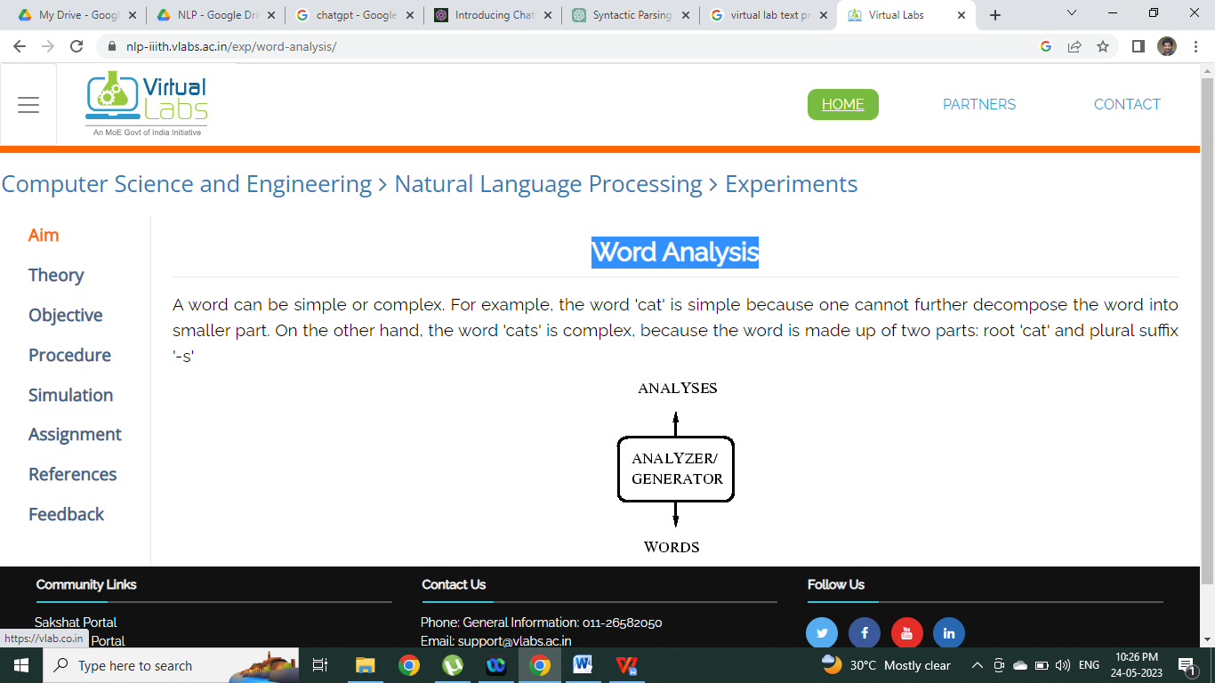

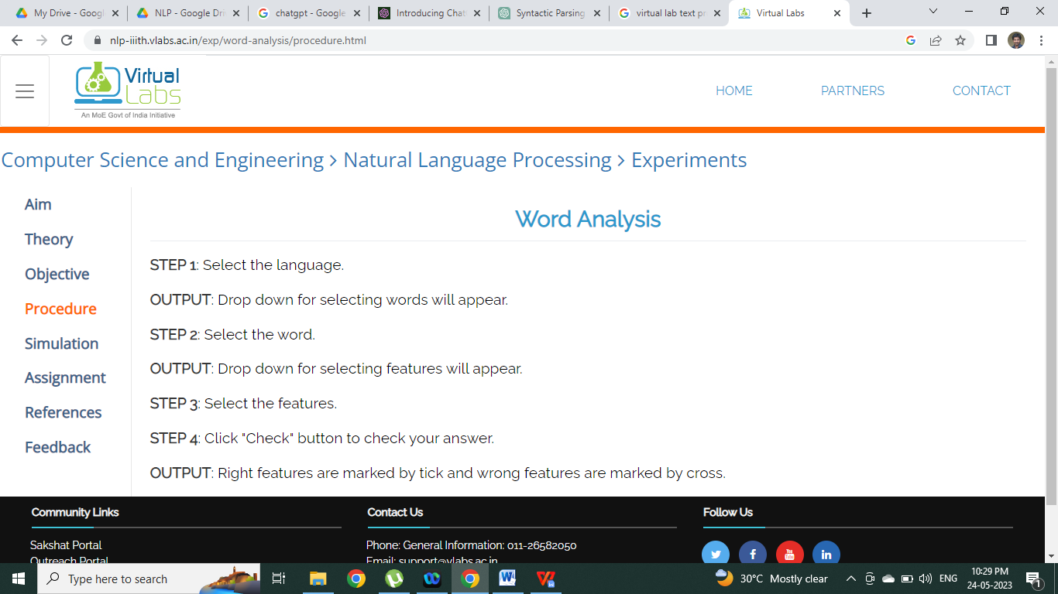

VIRTUAL LAB LINKS: https://nlp-iiith.vlabs.ac.in/exp/word-analysis/
Ex No: 15 | IMPLEMENTATION OF POS TAGGING - HIDDEN  MARKOV MODEL
Date : | IMPLEMENTATION OF POS TAGGING - HIDDEN  MARKOV MODEL

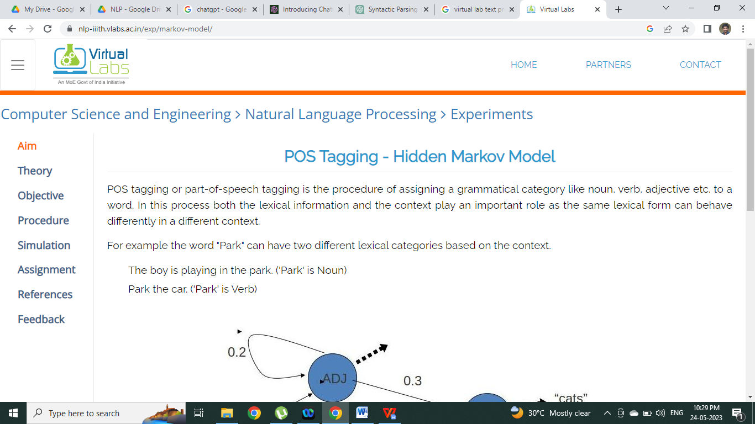

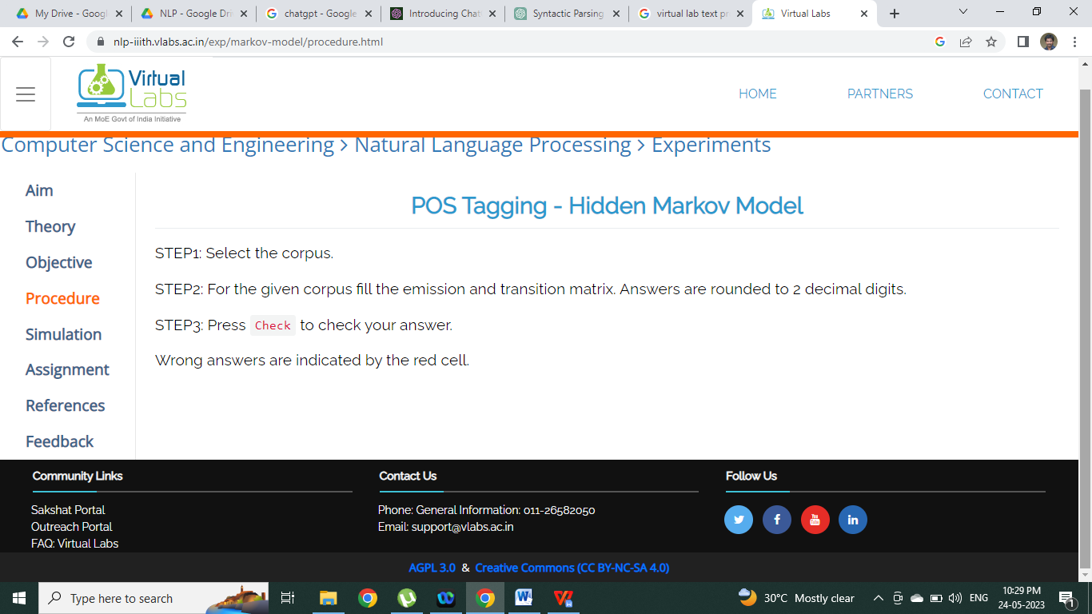

VIRTUAL LAB LINKS:
https://nlp-iiith.vlabs.ac.in/exp/markov-model/

